Prelim Skills Exam

Developing Applications and Automation (CPE028)

Joshua A. Taway

Copy screenshots of python codes and simulation output. Make sure to include your name.

1. Creating Virtual Environment (10 points)
   1. Create a python 3 virtual environment. Use your name and then DevOps as a virtual environment name. Example villanueva_devops

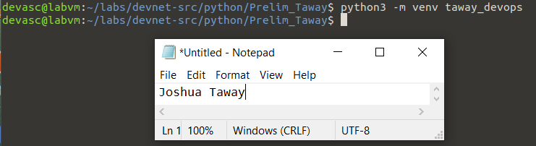

* 1. Activate the virtual environment.

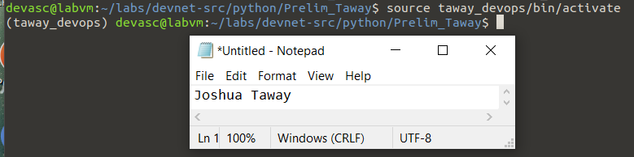

* 1. 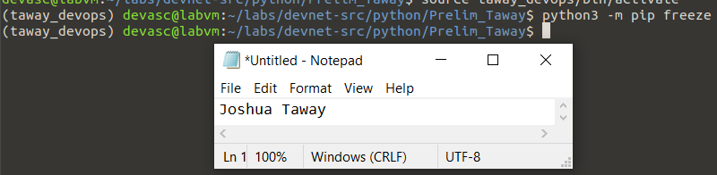Execute a command to check what packages are installed in the system environment.
  2. Create requirements.txt and, then execute a command to install the packages as stated in the requirements.txt (Note: Install at least four (4) packages)

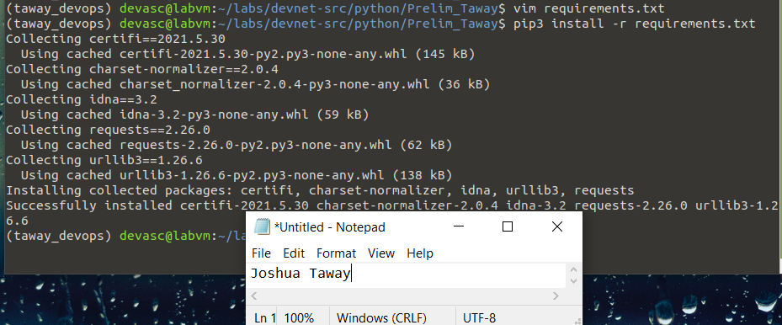

1. Create a python Unit Test (15 points)

Create at least 4 test cases of the python unit test to test the given python script.

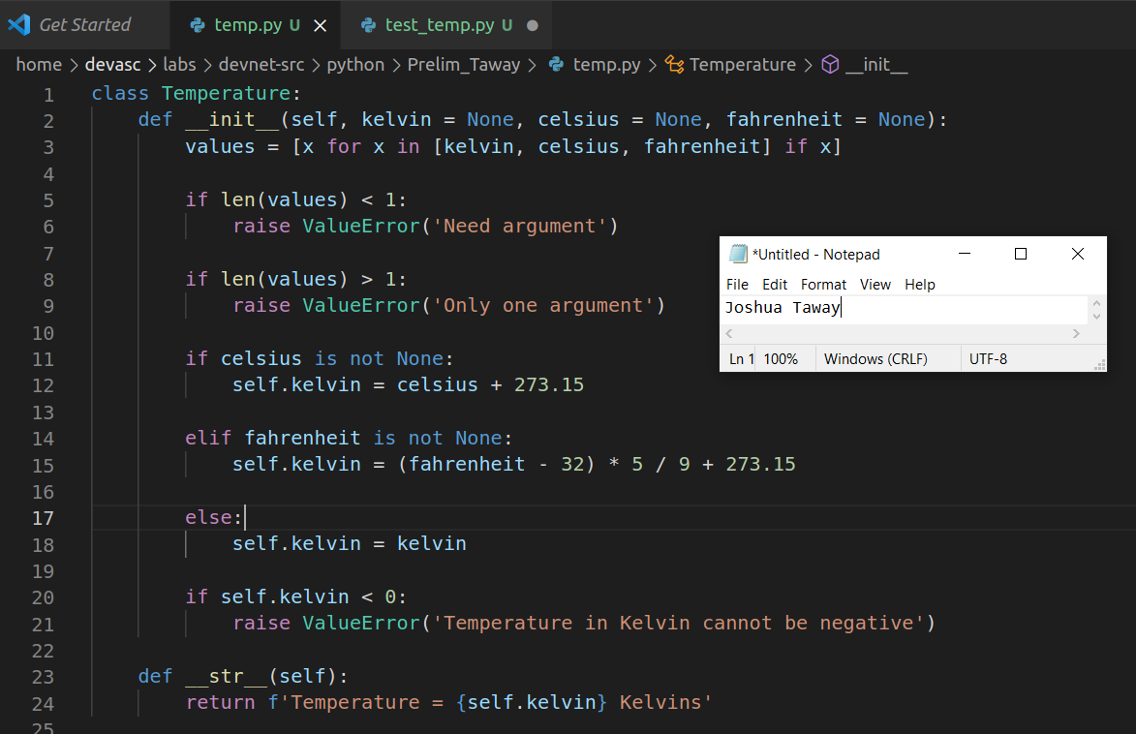

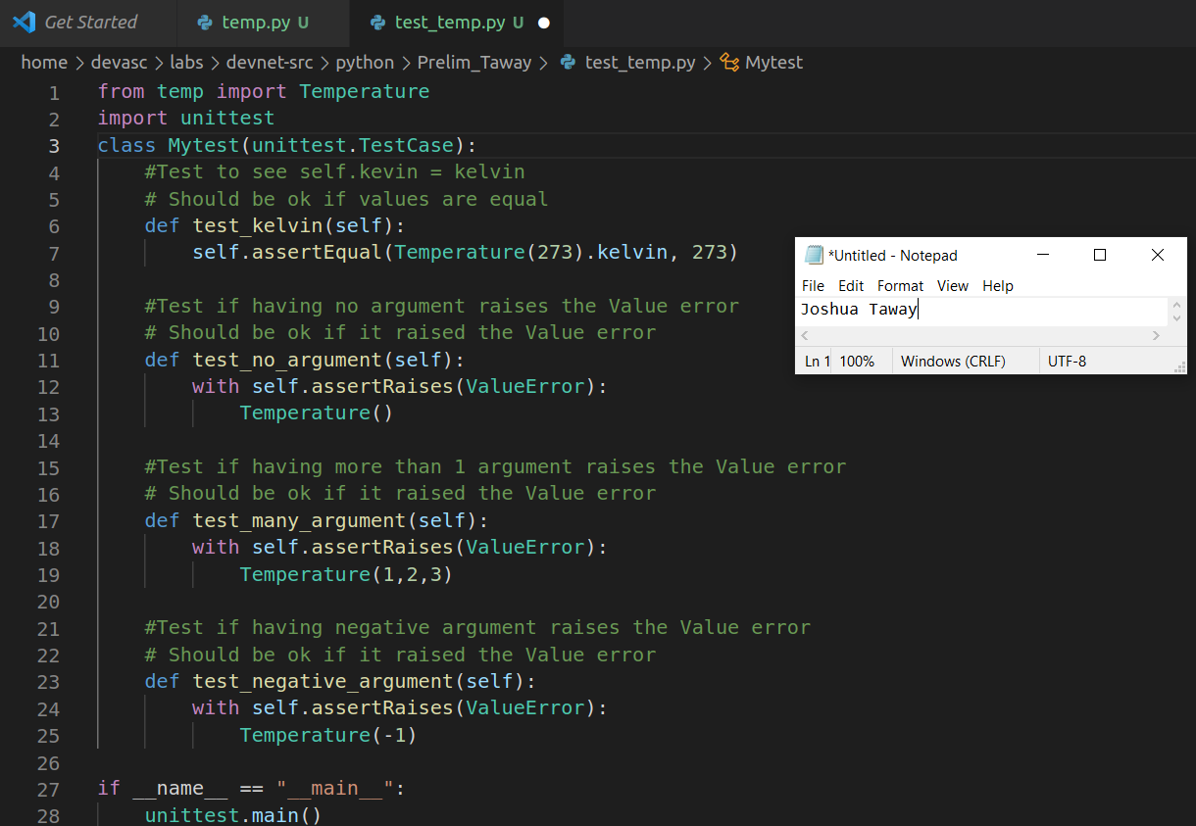

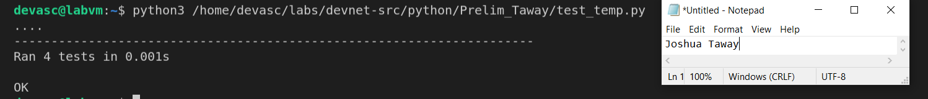

1. Parsing Different Data Types with Python (20 points)

Parse the given JSON / XML file for COVID cases. Retrieve the date reported, countries and territories, number of cases, and deaths. Create a new CSV file and then save the retrieved data to the CSV file.

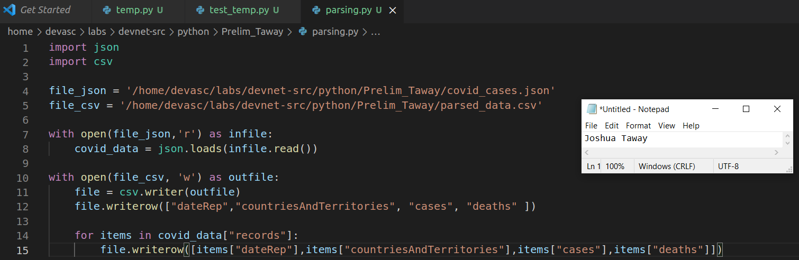

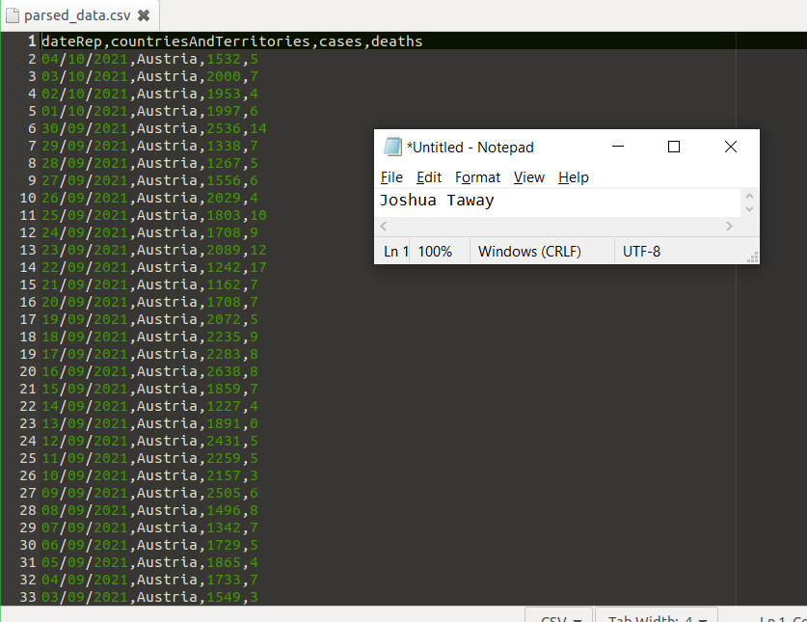

1. Git Commands (5 points)
   1. Create a repository PRELIM_SKILLS_EXAM to your GITHUB account.

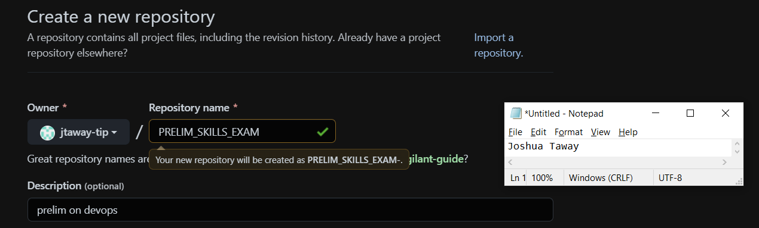

* 1. Upload your files using the GIT command. Make sure to include the necessary comments.

